Assembly of legs on Findus dress up trolley item.nr 35329 and Jubel dress up trolley item.nr 35655.
- Place trolley lying with short side facing upwards.
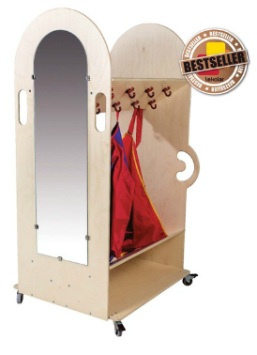
- Loosen the four screws marked in below picture with a hexagon key.

- Place the board (leg) so that the screw holes match each other. Attach the four screws again.
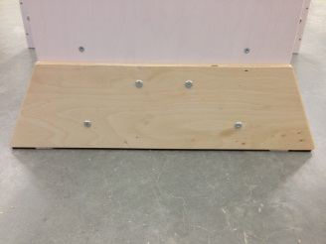

- Flip the cart and repeat the same procedure on the other side of the trolley.

- When legs are attached, carefully flip the trolley so that it stands upright again.

*Please note that this product is not a toy and shall therefor only be used under supervision by an adult.*

